Regional Site
How to maintain the Regional Sites
11/10/08 by Michelle Pakron (please email mpakron@stei.com for help issues)

The instructions below are generic and apply to all regional sites.

Structure:
The site currently consists of the following content areas:

Announcements: lists that allows admin users to add news announcements to the site.
Calendar: Admins may add events to the calendar
Reports Files: Library for adding report files
News Files: Library for adding news files

Home page:
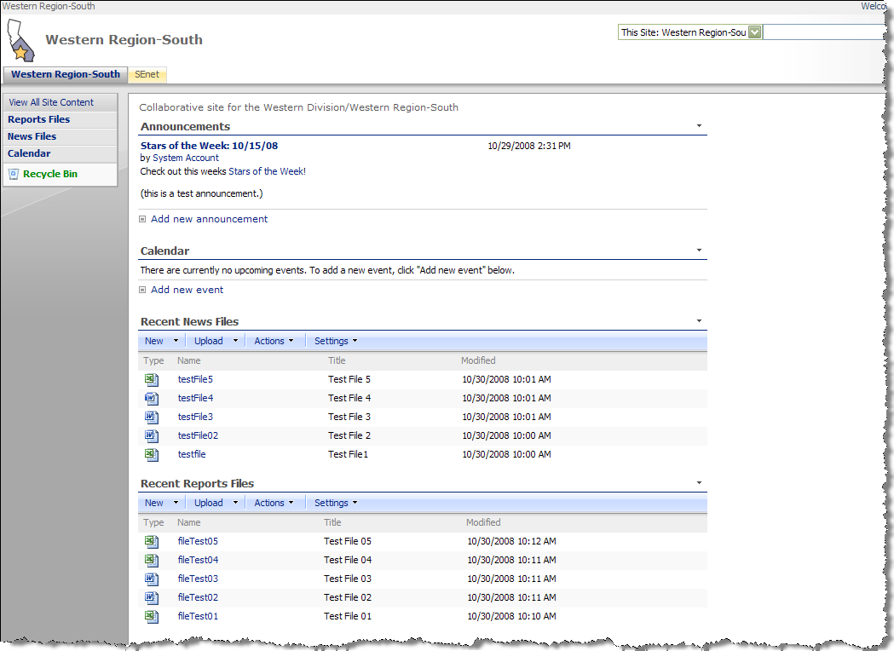

The home page has four areas that lead to more content. The Announcements list displays the most current announcements. The Calendar list displays upcoming events. Recent News Files display the 5 most recent News files. Recent Report files display the 5 most recent Report files.

Announcements:

Adding Announcements:
Click the Announcements header link:
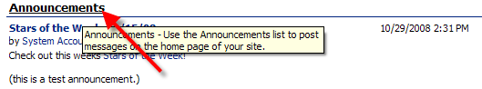

The Announcements list will display:
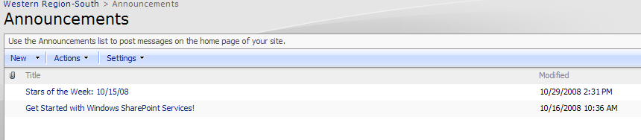

To add an announcement, click New > New Item:
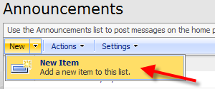

The New Announcement screen will display:
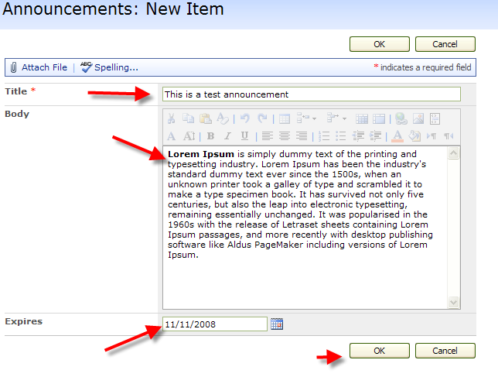
Add a Title, Click in the Body field to add content, and if you want the announcement to expire (auto-delete) add a date in the Expires field. Click OK.

The newly added announcement will then display in the Announcements list:
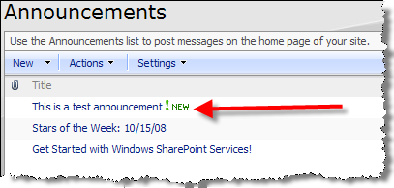

Editing Announcements:
Rollover the title of an announcement, click on the arrow that displays, and select Edit Item from the drop-down menu that displays:

The Edit Announcement screen will then display. Make any corrections necessary and click OK. To delete the item, click the Delete Item link.
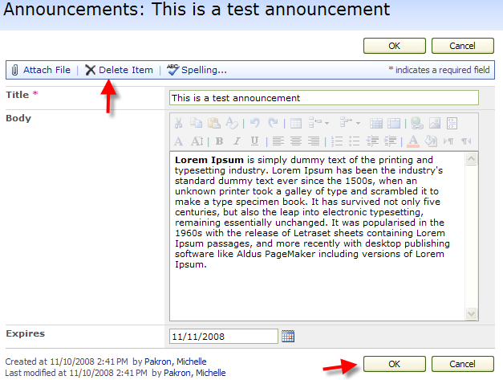

Viewing individual Announcements:
To view a displayed Announcement, click the title of the announcement:
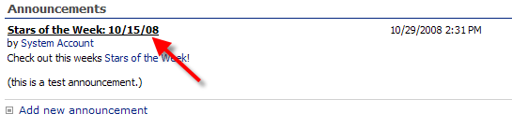

The announcement will then display on screen. Depending on the security level of the user, action buttons will display (New Item, Edit Item, Delete Item, etc.).

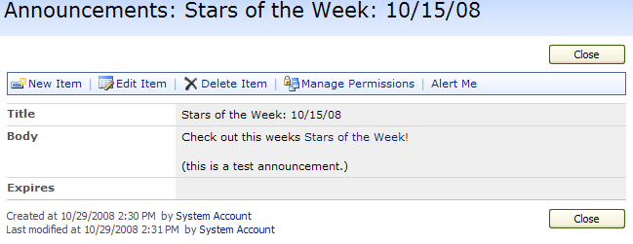

Calendar:

Adding events:
To add an even to the calendar, click the Calendar link header on the home page, or the Calendar link in the left-hand navigation area:

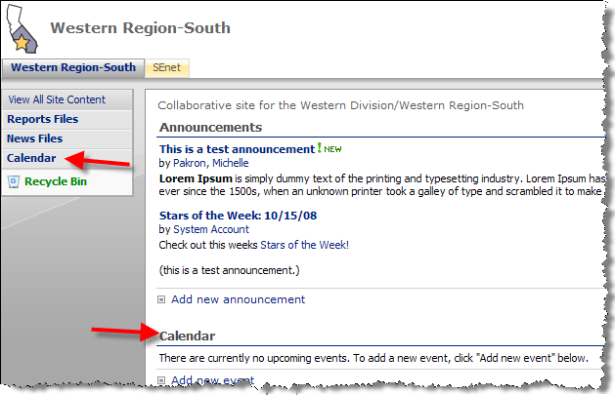

The full calendar page will then display. If you click a date on the calendar, the screen will display the hour by hour for the day:

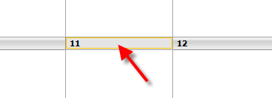
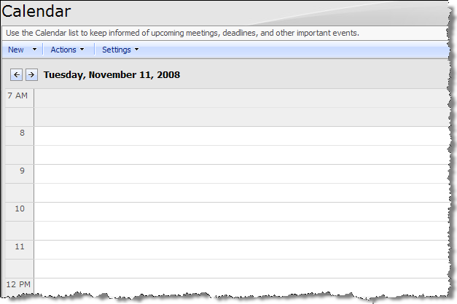
To add an event for the day, go to New > New Item:

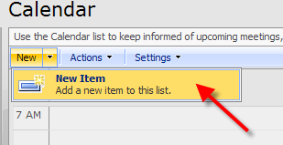

The New Item screen will display. Add a Title, Location, Start Time, End Time, and optionally a Description, choose whether or not it is an All Day Event, choose whether or not it is a recurring event by clicking the Recurrence box, and lastly, choosing whether or not to create a Workspace for the event. A Workspace is a subsite organized for storing information about an event. Click OK.

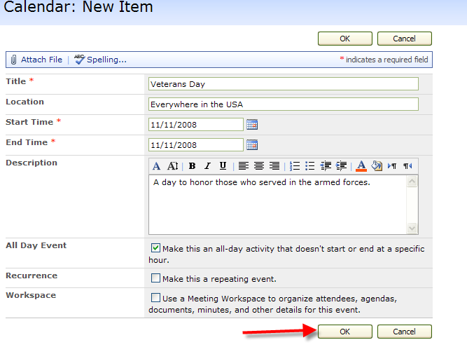

The newly added event will then display on the day:

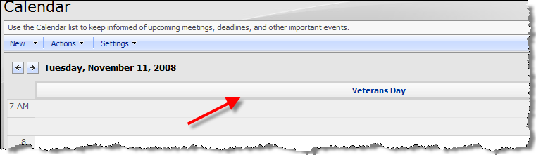

You may view the calendar by Day, Week or Month by clicking the corresponding link on the top right of the calendar:

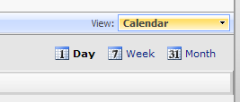

Month view:

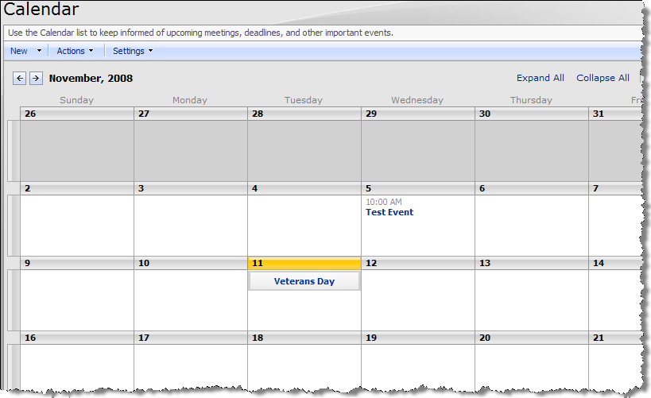

Home page display:
Newly added items will also display on the home page of the site:

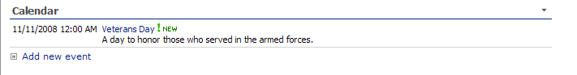

Editing Items:
To edit a calendar item, from the home page, click the title of the event:

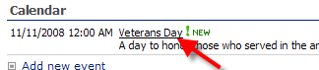

From the Calendar page, click the title of the event:

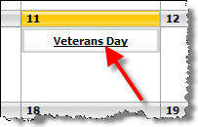

The event information will then display:

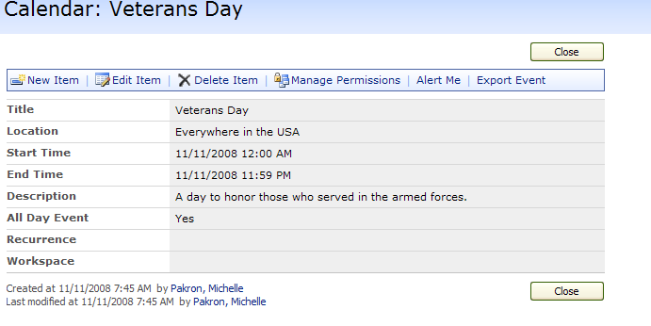

Those with admin access will see the Edit Item and Delete Item links. Click Delete Item to delete the event. Click Edit Item to edit the event.

Reports Files:

Viewing Reports Files:
There are two ways to get to the Reports Files list. Click the Recent Reports Files header link on the home page, or the Reports Files link in the left-hand navigation area:

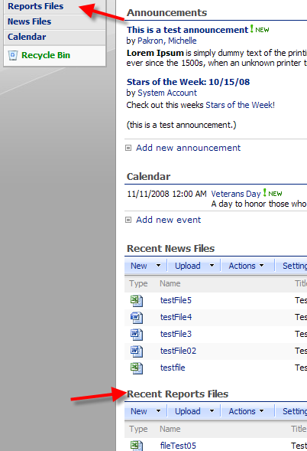

The Reports Files list will then display. Clicking the Name of a file will open the file.

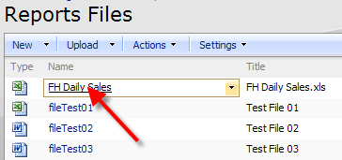

Adding a file:
To add a single file, go to Upload > Upload Document. To add multiple files, go to Upload > Upload Multiple Documents:

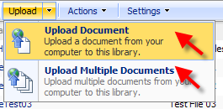

Single Files: the Upload Document screen will display. Use the Browse button to navigate to the file you wish to upload. Click OK to add the file:

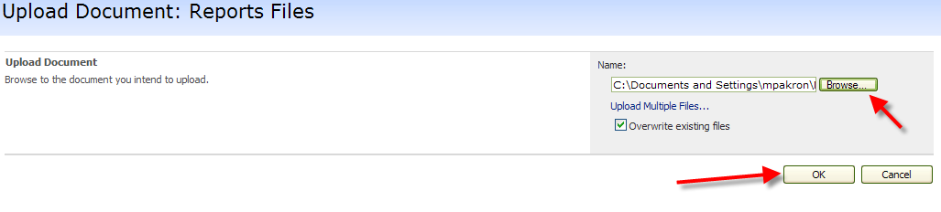
The Edit Form will then display, allowing you to change the Name of the document (remove spaces and all other characters except letters, numbers, underscores and hyphens), the Title, and you may also add a description. Click OK:

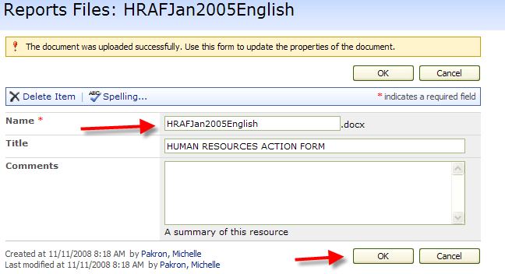

The newly added file will then display in the Reports Files list:

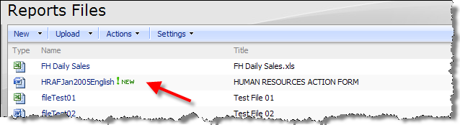

Multiple Files: the add multiple files screen will display. Navigate to the files you wish to add, clicking the checkbox next to each file. Click OK to add the files:

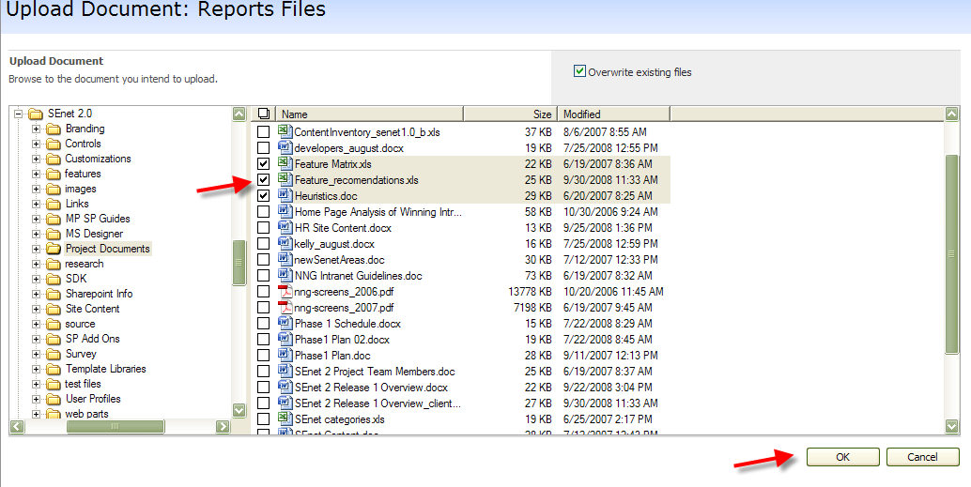

When you add multiple files, the Edit Form does not display. The files are added directly to the Reports Files list:

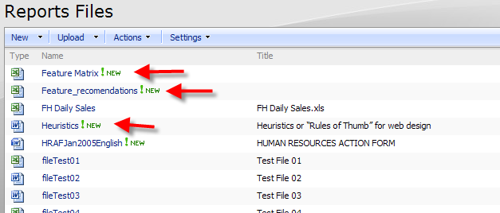
To add information for the newly added files, and to edit any file, rollover the Name of the file and click the arrow that displays. Select Edit Properties from the dropdown:

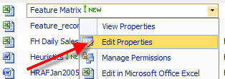

The Edit Form will then display. Please make sure for each file that is added to the library that the Name is cleared of any spaces or non-allowed characters. Click OK to finish:

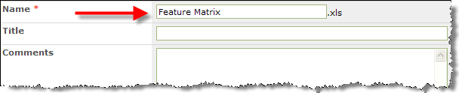

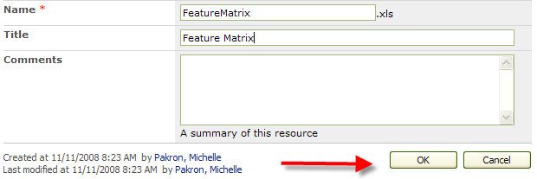

Deleting Files:
To Delete a file, you may click the Delete Item link in the Edit Form screen for a file or choose Delete Item from the dropdown that displays when you click the arrow that displays when you rollover the name of the file:

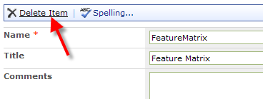
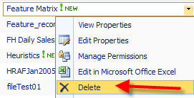

News Files:
The News Files list works the same way as the Reports File list.

